Unemployment Rate in Stanislaus County
May 20th, 2021

Contact: Nghi Nguyen, Workforce Development Data Analyst
Email: nguyenn@stanworkforce.com
Phone: (209)558-2105

Table of Contents
Introduction 1
I. Unemployment Overview (General) 2
1. California Counties 2
2. Stanislaus County 4
II. Unemployment Rate Overview (Pandemic Hit and Bounce Back) 8
III. Employment Overview by Industry (Pandemic hit) 11
1. California State 12
2. Stanislaus County 13
3. Los Angeles County 15
IV. Employment Overview by Industry (Bounceback) 19
1. California State 19
2. Stanislaus County 19
3. Los Angeles County 20
V. Job Postings and Future Trend 22
VI. Unemployment Rate Forecasting 26
Summary 30

Introduction
Most Federal funds are allocated through formula grants to the States based on specific factors, such as the unemployment rate, the share of disadvantaged adults or youth, or other factors. States then distribute the funding to local areas. This analysis will focus on the unemployment rate only.
First, the Federal funding amount depends on the general circumstance of the State. This funding is limited even when the unemployment rate in California is soaring as other States might be going through tougher conditions and more in need of funding.
Second, when the State receives the funding amount, other local counties may also be in more dire situations than Stanislaus County, necessitating greater distribution of funding.
Thus, analyzing Stanislaus County alone is not enough to determine the Federal funding amount required in the future. Other counties in California and other States’ situations also need to be considered. Some considerations for this analysis:
- Civilian labor force data is identified by place of residence, and includes self-employed individuals, unpaid family workers, household domestic workers, and workers on strike. Unemployment data also follows Civilian labor force data.
- Industry employment is identified by place of work and excludes self-employed individuals, unpaid family workers, household domestic workers, and workers on strike.
The purpose of this analysis is to identify and forecast the unemployment rate in Stanislaus County based on historical unemployment data, the employment normalization level in the post-pandemic period, and the new economic structure that will be pointed out in the later chapters.

I. Unemployment Overview (General)
1. California Counties
COUNTY | 2016 | 2017 | 2018 | 2019 | 2020
STATE TOTAL | 5.5% | 4.8% | 4.3% | 4.2% | 10.1%
ALAMEDA | 4.3% | 3.7% | 3.1% | 3.0% | 8.8%
ALPINE | 6.5% | 6.2% | 4.6% | 5.2% | 11.2%
AMADOR | 6.0% | 5.0% | 4.1% | 3.9% | 9.1%
BUTTE | 6.6% | 5.8% | 5.1% | 5.2% | 9.2%
CALAVERAS | 5.7% | 4.8% | 4.1% | 3.9% | 7.6%
COLUSA | 15.6% | 14.3% | 13.3% | 13.0% | 16.0%
CONTRA COSTA | 4.5% | 3.9% | 3.2% | 3.1% | 8.9%
DEL NORTE | 7.5% | 6.5% | 5.8% | 5.9% | 9.5%
EL DORADO | 5.2% | 4.4% | 3.7% | 3.6% | 8.3%
FRESNO | 9.5% | 8.6% | 7.6% | 7.4% | 11.3%
GLENN | 8.4% | 7.5% | 6.6% | 6.2% | 8.9%
HUMBOLDT | 4.9% | 4.2% | 3.6% | 3.7% | 8.4%
IMPERIAL | 24.2% | 19.7% | 18.8% | 20.9% | 22.5%
INYO | 5.3% | 4.4% | 3.9% | 3.6% | 7.8%
KERN | 10.4% | 9.3% | 8.1% | 7.9% | 12.5%
KINGS | 10.0% | 9.0% | 7.9% | 8.0% | 11.6%
LAKE | 6.7% | 5.8% | 5.3% | 5.2% | 9.6%
LASSEN | 7.0% | 5.6% | 4.8% | 4.7% | 7.1%
LOS ANGELES | 5.3% | 4.8% | 4.7% | 4.6% | 12.8%
MADERA | 9.3% | 8.2% | 7.1% | 7.0% | 10.8%
MARIN | 3.3% | 2.9% | 2.4% | 2.4% | 6.7%
MARIPOSA | 6.9% | 5.9% | 5.4% | 4.6% | 10.9%
MENDOCINO | 5.3% | 4.5% | 4.0% | 4.0% | 8.9%
MERCED | 10.6% | 9.4% | 8.5% | 8.2% | 12.2%
MODOC | 7.8% | 8.2% | 7.6% | 7.2% | 8.5%
MONO | 5.4% | 4.5% | 4.1% | 3.8% | 11.8%
MONTEREY | 7.7% | 7.2% | 6.4% | 6.4% | 10.8%
NAPA | 4.3% | 3.7% | 3.0% | 2.9% | 8.7%
NEVADA | 4.8% | 4.1% | 3.5% | 3.4% | 8.0%
ORANGE | 4.1% | 3.5% | 3.0% | 2.8% | 8.8%
PLACER | 4.5% | 3.9% | 3.2% | 3.2% | 7.3%
PLUMAS | 9.8% | 8.9% | 7.6% | 7.8% | 10.7%
RIVERSIDE | 6.1% | 5.3% | 4.5% | 4.2% | 9.9%
SACRAMENTO | 5.4% | 4.7% | 3.9% | 3.7% | 9.3%
SAN BENITO | 6.7% | 5.8% | 5.1% | 5.0% | 9.9%
SAN BERNARDINO | 5.8% | 5.0% | 4.1% | 3.9% | 9.4%
SAN DIEGO | 4.7% | 4.0% | 3.4% | 3.3% | 9.2%
SAN FRANCISCO | 3.3% | 2.9% | 2.4% | 2.2% | 7.8%
SAN JOAQUIN | 8.2% | 7.0% | 6.1% | 6.0% | 11.3%
SAN LUIS OBISPO | 4.3% | 3.6% | 3.0% | 2.9% | 7.7%
SAN MATEO | 3.1% | 2.7% | 2.3% | 2.1% | 6.9%
SANTA BARBARA | 5.1% | 4.6% | 4.0% | 3.7% | 8.0%
SANTA CLARA | 3.8% | 3.2% | 2.7% | 2.5% | 7.0%
SANTA CRUZ | 7.0% | 5.7% | 5.0% | 5.0% | 9.5%
SHASTA | 7.0% | 5.8% | 5.0% | 4.8% | 8.7%
SIERRA | 7.6% | 6.6% | 6.1% | 5.4% | 8.0%
SISKIYOU | 8.5% | 7.3% | 6.8% | 6.6% | 9.7%
SOLANO | 5.5% | 4.8% | 4.0% | 3.8% | 9.5%
SONOMA | 4.0% | 3.4% | 2.8% | 2.7% | 7.9%
STANISLAUS | 8.6% | 7.5% | 6.5% | 6.2% | 10.7%
SUTTER | 9.7% | 8.8% | 7.7% | 7.5% | 11.0%
TEHAMA | 7.1% | 6.4% | 5.8% | 5.7% | 8.8%
TRINITY | 7.1% | 6.2% | 5.8% | 5.6% | 8.0%
TULARE | 11.2% | 10.5% | 9.8% | 9.9% | 13.2%
TUOLUMNE | 6.2% | 5.4% | 4.7% | 4.6% | 10.4%
VENTURA | 5.2% | 4.5% | 3.8% | 3.7% | 8.6%
YOLO | 5.9% | 5.1% | 4.3% | 4.2% | 7.5%
YUBA | 8.6% | 7.5% | 6.5% | 6.2% | 10.5%
Figure I.1: Annual Average Unemployment rate of all counties in California from 2016 to 2020. Data not seasonally adjusted (Source: Unemployment Rate and Labor Force (ca.gov))

Figure I.2 shows the top 10 Counties with the highest Unemployment Change Rate from 2019 to 2020. The unemployment rate of change is the percentage change in value over a period of time, in this case, the period is from 2019 to 2020.

Formula:
$$Rate of Change=\left(\frac{\# ofunemployment in 2020}{\# of unemployment in 2019}-1\right)*100\%$$

Source for the number of unemployment: Unemployment Rate and Labor Force (ca.gov). The data were collected and combined by the author of the analysis.

Figure I.1 indicates that the unemployment rate of all 10 counties had been decreasing from 2016 to 2019. When COVID-19 hit the U.S. in 2020, unemployment claims raised sharply. San Francisco, San Mateo, Orange, Mono, Napa, Alameda, San Diego, Contra Costa, Sonoma, and Los Angeles are the most affected Counties in California by figure I.2.

Figure I.2: Top 10 Counties in California that have the highest rate of annual average Unemployment Change Rate from 2019 to 2020. (Source: Unemployment Rate and Labor Force (ca.gov))

2. Stanislaus County
The unemployment rate in Stanislaus County in 2020 is about 10.7%, which is slightly higher than in California, around 10.1% (figure I.1)
Figure I.3 shows the Rank by Unemployment Rate of Stanislaus County among all counties in California from 2016 to 2020. Rank 1st means having the least unemployment rate. Over the last 5 years, the rank of Stanislaus County has been decreasing, from 47 in 2016 to 42 in 2020.
- There are 58 counties in California, and two counties might have the same rank if they have the same unemployment rate up to the first decimal place. Thus, the number of unemployment claims in Stanislaus County is still high compared with other counties in California.
- Although 2020 is when COVID-19 began, the rank trend is stable (gradually decreasing).

Figure I.3: Stanislaus County’s Rank by annual average Employment Rate from 2016 to 2020 (Source: Unemployment Rate and Labor Force (ca.gov))

Figure I.4 shows all the counties in California which have a higher unemployment rate than Stanislaus County in 2019.

Figure I.4: Counties having annual average unemployment rates which are higher than Stanislaus County’s unemployment rate in 2019 (Source: Unemployment Rate and Labor Force (ca.gov))

Figure I.5 shows all the counties in California which have a higher unemployment rate than that of Stanislaus County in 2020.

Figure I.5: Counties having annual average unemployment rates which are higher than Stanislaus County’s unemployment rate in 2020 (Source: Unemployment Rate and Labor Force (ca.gov))

The number of counties that have higher unemployment rates than Stanislaus County increased from 14 counties in 2019 to 16 counties in 2020, indicating that some counties needed more substantial help from the federal funding in the pandemic time.

II. Unemployment Rate Overview (Pandemic Impact & Bounce Back)
The unemployment rate in all counties in California peaked in April 2020 (Source: Local Area Unemployment Statistics (LAUS) | EDD Data Library). To determine the industry that was affected the most by COVID-19, it is important to look at the periods from March 2020 to April 2020 as the pandemic hit stage and April 2020 to March 2021 as the recovery stage.
Figure II.1 notes the unemployment rate change for all counties in California from March 2020 to April 2020, from April 2020 to March 2021, and from March 2020 to March 2021. The order follows the Change Mar20-Mar21 column (4th column) from largest to smallest number. Formula:
Change Mar20-Apr20 = April 2020 Unemployment Rate – March 2020 Unemployment Rate
Change Apr20-Mar21 = March 2021 Unemployment Rate – April 2020 Unemployment Rate
Change Mar20-Mar21 = March 2021 Unemployment Rate – March 2020 Unemployment Rate

March 2020 – April 2020:
Mono County (No.3) was affected the most by COVID-19 with a 23.8% unemployment rate increase from March 2020 to April 2020. By comparison, Stanislaus County (No.38) increased by 9.6% (figure II.1).

April 2020 – March 2021
Counties in California are recovering after the unemployment rate changes from April 2020 to March 2021 were all negative. Mono County (No. 3) made the fastest comeback with the unemployment rate decreased by 20.5%. The unemployment rate in Stanislaus County (No.38) decreased by 8.5% from April 2020 to March 2021.

March 2020 – March 2021
The presence of the fourth column, Change Mar20-Mar21, is to point out whether the economy had fully recovered. 47 over 58 counties had unemployment rates in March 2021 equal to or higher than that in March 2020, indicating that most regions had not fully recovered in terms of unemployment.
The unemployment rate of Los Angeles County in March 2021 remained higher than that was in March 2020 (No.1). Besides, Colusa County (No.58) has done a spectacular job in reducing unemployment when the unemployment rate declined by 5.8% in March 2020 compared to March 2020. Stanislaus County (No. 38) has been doing well with only a 1.1% unemployment rate increase from March 2020.
Some impressive data come from Imperial County (No. 57) and Colusa County (No. 58) with the unemployment rate dropped by 4.4% and 5.8% respectively.

No. | County | Change  Mar20-Apr20 | Change  Apr20-Mar21 | Change  Mar20-Mar21
1 | Los Angeles County | 12.6% | -7.2% | 5.4%
2 | San Bernardino County | 9.8% | -6.5% | 3.3%
3 | Mono County | 23.8% | -20.5% | 3.3%
4 | Contra Costa County | 11.5% | -8.4% | 3.1%
5 | Solano County | 11.1% | -8.0% | 3.1%
6 | San Diego County | 12.1% | -9.1% | 3.0%
7 | Sacramento County | 10.6% | -7.6% | 3.0%
8 | Orange County | 11.1% | -8.1% | 3.0%
9 | Alameda County | 11.1% | -8.2% | 2.9%
10 | Riverside County | 11.3% | -8.4% | 2.9%
11 | Napa County | 14.1% | -11.3% | 2.8%
12 | San Francisco County | 10.2% | -7.6% | 2.6%
13 | Sonoma County | 12.1% | -9.5% | 2.6%
14 | Mariposa County | 13.7% | -11.1% | 2.6%
15 | Amador County | 10.3% | -7.8% | 2.5%
16 | San Mateo County | 9.3% | -6.9% | 2.4%
17 | Tuolumne County | 14.0% | -11.7% | 2.3%
18 | San Luis Obispo County | 11.3% | -9.0% | 2.3%
19 | Humboldt County | 10.8% | -8.6% | 2.2%
20 | Ventura County | 10.3% | -8.1% | 2.2%
21 | Alpine County | 17.4% | -15.2% | 2.2%
22 | Santa Clara County | 9.2% | -7.1% | 2.1%
23 | Inyo County | 10.5% | -8.5% | 2.0%
24 | El Dorado County | 11.3% | -9.3% | 2.0%
25 | Marin County | 9.3% | -7.4% | 1.9%
26 | Nevada County | 11.2% | -9.3% | 1.9%
27 | Yuba County | 8.5% | -6.7% | 1.8%
28 | Placer County | 9.6% | -7.8% | 1.8%
29 | Mendocino County | 10.3% | -8.5% | 1.8%
30 | Santa Barbara County | 9.1% | -7.4% | 1.7%
31 | San Joaquin County | 10.4% | -8.8% | 1.6%
32 | Del Norte County | 7.6% | -6.2% | 1.4%
33 | Calaveras County | 8.8% | -7.4% | 1.4%
34 | Lake County | 9.4% | -8.1% | 1.3%
35 | Shasta County | 9.5% | -8.2% | 1.3%
36 | Butte County | 9.8% | -8.5% | 1.3%
37 | San Benito County | 11.8% | -10.6% | 1.2%
38 | Stanislaus County | 9.6% | -8.5% | 1.1%
39 | Yolo County | 6.4% | -5.4% | 1.0%
40 | Tehama County | 7.8% | -6.8% | 1.0%
41 | Santa Cruz County | 10.2% | -9.4% | 0.8%
42 | Siskiyou County | 6.4% | -6.3% | 0.1%
43 | Fresno County | 7.3% | -7.2% | 0.1%
44 | Kern County | 7.6% | -7.5% | 0.1%
45 | Lassen County | 4.9% | -4.9% | 0.0%
46 | Plumas County | 6.8% | -6.8% | 0.0%
47 | Sutter County | 7.5% | -7.5% | 0.0%
48 | Madera County | 7.8% | -7.9% | -0.1%
49 | Merced County | 6.9% | -7.1% | -0.2%
50 | Sierra County | 6.5% | -6.9% | -0.4%
51 | Glenn County | 6.4% | -7.0% | -0.6%
52 | Monterey County | 7.9% | -8.6% | -0.7%
53 | Trinity County | 5.0% | -5.8% | -0.8%
54 | Kings County | 5.6% | -6.4% | -0.8%
55 | Modoc County | 3.0% | -4.1% | -1.1%
56 | Tulare County | 5.4% | -7.0% | -1.6%
57 | Imperial County | 8.5% | -12.9% | -4.4%
58 | Colusa County | 4.3% | -10.1% | -5.8%
Figure II.1: Unemployment Rate Change of all counties in California from March 2020 to April 2020 and from April 2020 to March 2021. Data not seasonally adjusted (Source: Unemployment Rate and Labor Force (ca.gov))

III. Employment Overview by Industry (Pandemic hit)
Since the historical data of the unemployment rate by occupations is not available, historical employment data is utilized as an alternative. The purpose of this section is to determine the industries/occupations that were most affected by the pandemic and use the results to analyze the circumstances and future economic trends of Stanislaus County.
The industries in this section follow the North American Industry Classification System (NAICS) code order. NAICS uses a six-digit hierarchical coding system to classify all economic activity into twenty industry sectors. “Five sectors are mainly goods-producing sectors and fifteen are entirely services-providing sectors.” (Source: North American Industry Classification System (NAICS) at BLS : U.S. Bureau of Labor Statistics)
To see the full list of Industries by Supersector and NAICS Code, please go to Industries at a Glance: NAICS Code Index (bls.gov)
The 11 industry sectors utilized in this section are (10 non-farm and 1 farm sectors):
- Educational and Health Services
- Financial Services
- Government
- Information
- Leisure and Hospitality
- Manufacturing
- Natural Resources, Mining and Construction
- Other Services
- Professional and Business Services
- Total Farm
- Trade, Transportation and Utilities
Formula for Employment Change Rate:
$$Rate of Change=\left(\frac{\# of employment in April 2020}{\# ofemployment in March 2020}-1\right)*100\%$$

Source for the number of unemployment: Unemployment Rate and Labor Force (ca.gov). The data were collected and combined by the author of the analysis.
NOTE: Industry Data does not include self-employed individuals, unpaid family workers, household domestic workers, and workers on strike.

1. California State
By March 2020, the biggest sector in California was Trade, Transportation & Utilities with about 17% of total state employment (figure III.1.1).

Figure III.1.1: California Employment by Industry by March 2020 (Source: Employment by Industry DatamyTemplate (ca.gov))

In California from March 2020 to April 2020, the Leisure and Hospitality industry reduced the number of jobs by 45.2%. The Leisure and Hospitality sector includes Arts, Entertainment, and Recreation and Accommodation and Food Services. Most of the activities in these subsectors were limited in the pandemic time due to shelter-in-place orders. Interestingly, that the number of jobs in the farm industry increased by 5.1% during this period.

Figure III.1.2: The employment change rate in California by Industry from March 2020 to April 2020 (Source: Industry Employment in California Counties | EDD Data Library)

2. Stanislaus County
Similar to the entire state, Trade, Transportation & Utilities was the biggest sector in Stanislaus County in March 2020 with approximately 19% of total county employment (figure III.2.1). The Government sector in the local area ranked third with roughly 16%. According to the 2020 County-Level Economic Forecast of California Department of Transportation (source: dot.ca.gov), most transportation jobs in Stanislaus County are trucking and warehousing. The county has prominent logistics and fulfillment centers for Amazon, Restoration Hardware, and others. During the Coronavirus crisis, transportation and warehousing employment did not decline substantially despite being a large industry sector. This is most likely due to the high demand for utility and online shopping.
Most Manufacturing jobs in Stanislaus County are related to agricultural commodities transformation into finished food and beverage products. Since the agricultural industry is large compared with other regions, Manufacturing occupies a fair portion at 11%.

Figure III.2.1: Stanislaus County Employment by Industry by March 2020 (Source: Employment by Industry DatamyTemplate (ca.gov))

From March to April 2020, all industries contracted in size. The sector that was most affected is Leisure and Hospitality. The number of jobs in the sector appeared to reduce by 36.1% (figure III.2.2).
Employment in the Information sector also dropped notably (by 20%) due to the downturn in media advertisement revenue.

Figure III.2.2: The employment change rate in Stanislaus County from March 2020 to April 2020 (Source: Industry Employment in California Counties | EDD Data Library)

3. Los Angeles County
For comparison purposes, Los Angeles County is used to represent a typical example of the area that is most affected by the pandemic. According to section II, Los Angeles County has the highest unemployment rate increase from March 2020 to March 2021, indicating that the area has not fully recovered from the pandemic recession in terms of unemployment
The largest industry sector in Los Angeles County as of March 2020 was Educational and Health Services, with around 19% of total employment. Professional and Business Services occupied a much larger portion in Los Angeles County (14%) compared to Stanislaus County (8%) (figure III.3.1). Professional and Business Services includes
- Professional, Scientific, and Technical Services
- Management of Companies and Enterprises
- Administrative and Support and Waste Management and Remediation Services

Figure III.3.1: Los Angeles County Employment by Industry by March 2020 (Source: Employment by Industry DatamyTemplate (ca.gov))

Figure III.3.2 shows that Leisure and Hospitality shrunk the most, approximately 43.9%. This data is much higher than the change rate of the same sector in California and Stanislaus County. Notice that Leisure and Hospitality includes hotel, restaurant, and bar activities which are quite popular in urban areas like Los Angeles.
The Professional and Business Services employment rate in Los Angeles County dropped by 11.5%, nearly double the rate drop of that in Stanislaus County, about 6.1%.
Manufacturing in Los Angeles heavily concentrates on food and beverage, clothing, computer and electronic, and aerospace, and the employment shrank by 13% from March 2020 to April 2020.

Figure III.3.2: The employment change rate in Los Angeles County from March 2020 to April 2020 (Source: Industry Employment in California Counties | EDD Data Library)

4. Comparison of Employment Change Rate
In terms of employment, California declined 13.9%, Stanislaus County declined 11.1%, and Los Angeles County declined 15.7% of total employment from March 2020 to April 2020. This indicates that Stanislaus County while affected by the pandemic, was not impacted as hard as other counties. The contraction of employment depicts the impacts of COVID-19 on the three regions in this comparison.

Figure III.4.1: The employment change in California, Stanislaus County, and Los Angeles County from March 2020 to April 2020 (Source: Industry Employment in California Counties)

IV. Employment Overview by Industry (Bounce Back)
This section focuses on the period after April 2020. The latest employment by industry statistics on U.S Bureau/EDD Labor Market is as of March 2021.

1. California State
Figure IV.1.1 notes the employment change rate in California from April 2020 to March 2021. Leisure and Hospitality has recovered quickly. The amount of employment increased by nearly 32.2%.
The only sector that has been shrinking is Government which decreased by 4.7%. Government agencies were expected to lose revenue from taxes and fees from 2020, and the situation may persist in 2021 and 2022. As a result, government agencies may have no choice but to make budget cuts.

Figure IV.1.1: The employment change rate in California from April 2020 to March 2021 (Source: Industry Employment in California Counties | EDD Data Library)

2. Stanislaus County
Leisure and Hospitality is also the sector that has recovered fastest in Stanislaus County, increasing by nearly 28.7% from April 2020 to March 2021 (figure IV.2.1). By contrast, Government (-5.3%) and Information (-25%) have contracted since April 2020. Information sector includes
- Public Industries
- Motion Picture and Sound Recording Industries
- Broadcasting
- Internet Publishing and Broadcasting
- Telecommunications
- Data Processing, Hosting, and Related Services
- Other Information Services
According to the 2020 County-Level Economic Forecast report (source: dot.ca.gov), in Stanislaus County, “Information sector is largely comprised of movie theaters and telecommunications companies like Comcast. While telecommunications jobs were not impacted as workers remained employed during shelter-in-place, movie theater employment diminished and many TV, radio, and newspapers.” Advertising revenues shrank with the result of the economy which led to the layoff notices.

Figure IV.2.1: The employment change rate in Stanislaus County from April 2020 to March 2021 (Source: Industry Employment in California Counties | EDD Data Library)

3. Los Angeles County
Los Angeles County is being used as a typical example of the region that was most affected by COVID-19.
Leisure and Hospitality bounced back 29.5% from April 2020. Although the number is approximate to that in California and Stanislaus County, notice that the sector in Los Angeles County shrunk much more than in California and Stanislaus County in April 2020 (part II). Thus, it is not because the rebound speed of Los Angeles is slower than that of Stanislaus County, it is because Los Angeles was hit hardest by the COVID-19 crisis.
Similar to California State and Stanislaus County, the Government sector has been declining since April 2020, by about 7.0%.

Figure IV.3.1: The employment change rate in Los Angeles County from April 2020 to March 2021 (Source: Industry Employment in California Counties | EDD Data Library)

V. Job Postings & Future Trends
The COVID-19 pandemic has led to many unprecedented changes, and the fundamental patterns of how we work might never be the same. The “After the Storm” report by Burning Glass Technologies published in February 2021 uses the database of more than 1 billion current and historical job postings to anticipate the job fields that will shape the recovery, including:
- The Readiness Economy: such as health care, cybersecurity, insurance, and other fields that provide social resilience
- The Logistics Economy: such as supply chains, manufacturing
- The Green Economy: such as renewables
- The Remote Economy
- The Automated Economy: such as automation and artificial intelligence
Notice that Leisure and Hospitality is a large industry sector in Stanislaus County, thus Health Care would probably have the opportunities to develop which will partly lead to the expansion of Readiness Economy. For other fields like Green, Remote, and Automated Economy, it will take time as the region needs to improve technological bases.
The Industry sectors reported might not illustrate the economic trends as a whole since it just shows the current situation of a region, not how the region would be driven in the future. To have a broader view of the employment trend of Stanislaus County, it is necessary to look at both pre and post-pandemic periods.

March 2019 – March 2020
From March 2019 to March 2020, the most in-demand occupational group was Healthcare Practitioners and Technical Occupations with 16,886 unique postings. The least in-demand group was Military-only Occupations with only four postings.
Computer and Mathematical Occupations ranks seventh with 2,875 open positions.
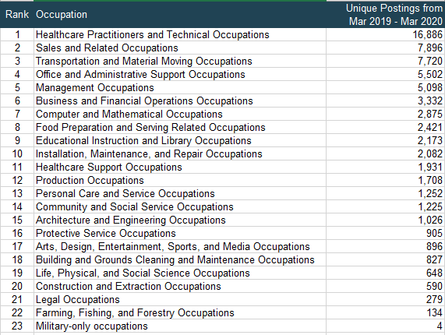
Figure V.1: Job Postings by Major Occupational Groups in Stanislaus County from March 2019 to March 2020 (Source: EMSI)

March 2020 – March 2021
From March 2020 to March 2021, Healthcare Practitioners and Technical Occupations remained the occupational group that had the highest number of job ads in Stanislaus County, and Military-only Occupations still ranked last with 16 postings.
The top five most in-demand occupational groups are the same in both periods.
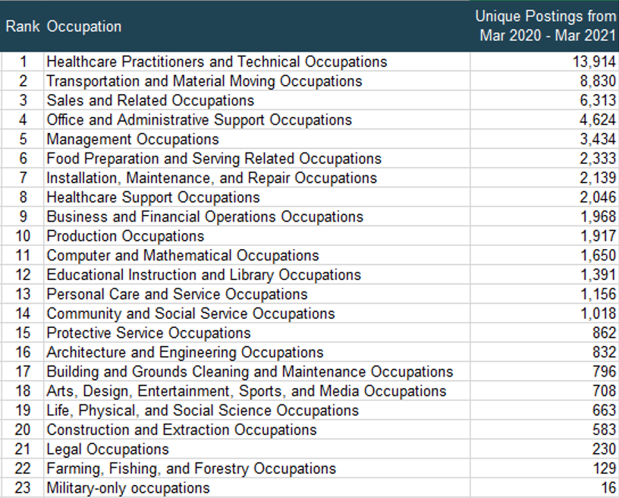
Figure V.2: Job Postings by Major Occupational Groups in Stanislaus County from March 2020 to March 2021 (Source: EMSI)

Comparison between the two periods
Change Rate Formula:
$$Rate of Change=\left(\frac{\# of job postings from Mar 20 to Mar 21}{\# of job postings from Mar 19 to Mar 20}-1\right)*100\%$$

Assuming that the periods of March 2019 – March 2020 and March 2020 – March 2021 are the pre-pandemic and post-pandemic period respectively. Table V.3 shows the change rate of job postings by major occupational groups of the two periods. In general, the needs of most occupational groups declined.
Since the number of job postings for Military-only Occupations was low compared with the others (only March 2020 and 16 in March 2021), we will focus on other groups. Transportation and Material Moving Occupations ranks 2nd in the table with a 14.4% increase. High-tech positions, such as Computer and Mathematical Occupations, were out of demand with a (-42.6%) reduction from the pre-pandemic period. Business and Financial Operations Occupations was in the same situation with the change rate of (-40.9%).
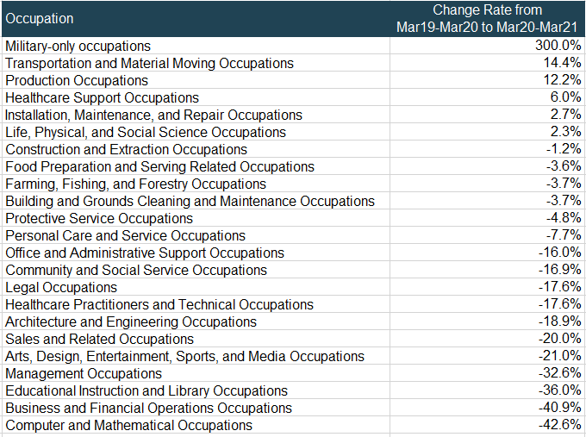
Figure V.3: Change Rate of Job Postings by Major Occupational Groups in Stanislaus County from March 2019 – March 2020 to March 2020 - March 2021 (Source: EMSI)

Except for the Healthcare occupations in the Readiness Economic field, there is no outstanding sign of a major change in the economic structure according to the data. There are two possibilities when comparing the predictions in the After the Storm report and the current situation in Stanislaus County:
- Stanislaus County has not yet started the process to transfer to the new structure and will shift gradually.
- The region will not shift to the new structure at least in the near future.

VI. Unemployment Rate Forecast in Stanislaus County
Long Term Trend- From 1990 to 2020, the unemployment rate of Stanislaus County trended downward (figure VI.1). Thus, in the long term, the number of unemployed individuals might be expected to fall. Notice that the pandemic has not had a huge impact as in 1993 or 2010 when the unemployment rate reached more than 19%.

Figure VI.1: Stanislaus County Unemployment Rate by year from 1990 to 2021, January each year (Source: EDD Labor Market Statistics)

Short Term Trend- From January 2019 to March 2021, figure VI.2 shows that the unemployment rate in Stanislaus County has the tendency to move upward, which was the likely effect of the COVID-19 pandemic.

Figure VI.2: Stanislaus County Unemployment Rate by Month from January 2019 to March 2021 (Source: EDD Labor Market Statistics)

Forecast Data-The following figure shows the economic forecast in Stanislaus County from the California Department of Transportation (forecast for all counties in California: Long-Term Socio-Economic Forecasts by County | Caltrans). The forecast was made after COVID-19 occurred. It was anticipated that the unemployment rate in Stanislaus County in 2020 would be 14.2%, which was far different from the actual number, about 10.7% in figure I.1.

Year | Employment Rate
2015 | 9.5%
2016 | 8.6%
2017 | 7.5%
2018 | 6.5%
2019 | 6.1%
2020 | 14.2%
2021 | 10.9%
2022 | 8.9%
2023 | 7.7%
2024 | 7.6%
2025 | 7.3%
2026 | 7.2%
2027 | 7.2%
2028 | 6.9%
2029 | 7.0%
2030 | 7.3%
Figure VI.3: Stanislaus County Unemployment Rate Forecast by Year (Source: from CalTrans)

As a result, this section will forecast the unemployment trend by considering different economic factors in the region. The unemployment rate in long term should decrease thanks to the government policies and subsidies. It is generally acknowledged that many businesses might close permanently, and the economy will not recover to pre-crisis status. 2022 and 2023 are the time for new businesses to open, workers, to become rehired, and income to be generated. The short-term forecast is complicated due to various factors that affect the unemployment rate:
- Labor force demographic characteristics (e.g. population, gender, age, skills, financial situation)
- Federal government/local authorities’ policies
- Region’s economics
- Black swan events (e.g. COVID-19 pandemic)
- Migrations
- Other factors

Case 1: Stanislaus County has not yet started the process to transfer to the new structure and will shift gradually.
- In the short term, the change in economic structure might create a time lag where the unemployment rate in the county would go up to adapt to new skill demands. The time lag might come from:
- Employers needing to provide/alter the technologies in the workplace
- The labor force needing to be trained for new skills
- Educational deficiencies in the workforce
The high short-term unemployment rate can be lessened by upskilling and reskilling programs. For example, employers could ask for financial aid from government upskilling programs instead of laying off unqualified employees and hire other skilled employees.
Shifting to the new economic structure also could benefit the regional economy. For example, automation lowers costs of production which enables lower price, leads to the creation of new kinds of jobs, and improves safety and remove the risk of human error. These benefits can increase the regional GDP.
Case 2: The region will NOT shift to the new structure at least in the near future.
In this case, the only tool to rely on is the historical unemployment rate data. The prediction would be that the unemployment rate would decrease in both the short and long term. However, this does not mean it will lead to better economic benefits than that in case 1 (e.g. GDP). Notice that the unemployment rate in Stanislaus County in the pre-pandemic period was high compared with other counties in California.
Although the first case might have a high unemployment rate in the near future, its long-term unemployment rate could be much lower than the long-term unemployment rate in case 2 (The economy in case 1 already takes time to build a skilled and experienced labor force). The economic contribution of the labor force in case 2 can be much higher than that in case 1.

Summary
This analysis has provided an overview of the economics of all counties in the State of California, with a focus on Stanislaus County. The unemployment rate in Stanislaus County is high compared with other regions in California (usually in the top twenty counties with the highest unemployment rate) in both pre-pandemic and post-pandemic periods.
The “After the Storm” report produced by Burning Glass Technologies indicates the five distinct fields that will shape the recovery, including:
- The Readiness Economy
- The Logistics Economy
- The Green Economy
- The Remote Economy
- The Automated Economy
It is reasonable to believe that the Stanislaus County economic structure, in general, will shift into those fields.
The Unemployment Rate prediction is based on the historical data trends and situational analysis such as pandemic recovery, economic trending, government policies that will favor the decline of unemployment, and so forth. The economic and workforce structure rely hugely on how Workforce Development steers the ship.

