STANISLAUS COUNTY
SECTOR STRATEGIES REPORT
Target Sectors:
- Agriculture | - Health Care
- Manufacturing | - Transportation and  Warehousing

Report Period: January 2020 – December 2020

Report Date: September 22nd, 2021
Contact: Nghi Nguyen, Workforce Data Analyst
Email: nguyenn@stanworkforce.com
Phone: (209)558-2105

Table of Contents
I. Agriculture, Forestry, Fishing and Hunting 1
1. Employment and Wage 1
2. Occupation 2
3. Job Postings 3
II. Health Care 5
1. Employment and Wage 5
2. Occupation 6
3. Job Postings 7
III. Manufacturing 9
1. Employment and Wage 9
2. Occupation 10
3. Job Postings 11
IV. Transportation and Warehousing 13
1. Employment and Wage 13
2. Occupation 14
3. Job Postings 15

I. Agriculture, Forestry, Fishing and Hunting
1. Employment and Wage
Total Employed as of Q4 2020: 14,651
Percent of Growth in historical employment (Q4 2010 – Q4 2020), annual Growth rate: 1.30%
Projected Growth Over 5 Years (Q4 2020 - 2025), annual growth rate: 0.51%
Number of People Employed (Historical 10 years, 2010-2020): 12,877 14,651

Figure I.1: Agriculture, Forestry, Fishing and Hunting Historical Employment Trend in Stanislaus County from Q4 2010 to Q4 2020

Average Employee Wage (Historical 10 years, 2010-2020): $25,692 $41,554

Figure I.2: Agriculture, Forestry, Fishing and Hunting Historical Wage Trend in Stanislaus County from 2010 to 2020
2. Occupation
Occupations by number of people employed in Agriculture as of Q4 2020
Description | Employed in Agriculture Industry as of Q4 2020 | Avg. Annual Earnings | Projected Job Change as of 2025
Packaging and Filling Machine Operators and Tenders | 1,681 | $36,275.20 | (2)
Laborers and Freight, Stock, and Material Movers, Hand | 1,148 | $37,003.20 | 1
Slaughterers and Meat Packers | 910 | $29,931.20 | (123)
Industrial Truck and Tractor Operators | 805 | $42,036.80 | (5)
Sales Representatives, Wholesale and Manufacturing, Except Technical and Scientific Products | 635 | $73,569.60 | 5
Miscellaneous Assemblers and Fabricators | 622 | $38,563.20 | (38)
First-Line Supervisors of Production and Operating Workers | 570 | $67,184.00 | 22
Industrial Machinery Mechanics | 542 | $62,337.60 | 58
Packers and Packagers, Hand | 501 | $32,052.80 | (0)
Food and Tobacco Roasting, Baking, and Drying Machine Operators and Tenders | 482 | $36,233.60 | (25)
Total Employed in Top 10 Occupations | 7,895
3. Job Postings
Top Ten Agriculture Job Postings (Jan 2020 – Dec 2020):
Occupation | Unique Postings from Jan 2020 - Dec 2020 | Median Annual Earnings | Median Advertised Salary
Farmworkers, Farm, Ranch, and Aquacultural Animals | 38 | $31,616 | $27,520
First-Line Supervisors of Farming, Fishing, and Forestry Workers | 23 | $49,899 | $29,312
Maintenance and Repair Workers, General | 22 | $47,050 | $100,000
Heavy and Tractor-Trailer Truck Drivers | 19 | $43,618 | $33,800
First-Line Supervisors of Production and Operating Workers | 14 | $62,982 | $47,616
Helpers--Production Workers | 13 | $30,867 | Insf. Data
First-Line Supervisors of Mechanics, Installers, and Repairers | 12 | $74,173 | $95,000
Office Clerks, General | 10 | $37,877 | Insf. Data
Production Workers, All Other | 10 | $36,899 | $28,032
Light Truck Drivers | 9 | $31,658 | $43,264

Companies with the highest number of distinct job posts - Agriculture (Jan 2020 – Dec 2020):
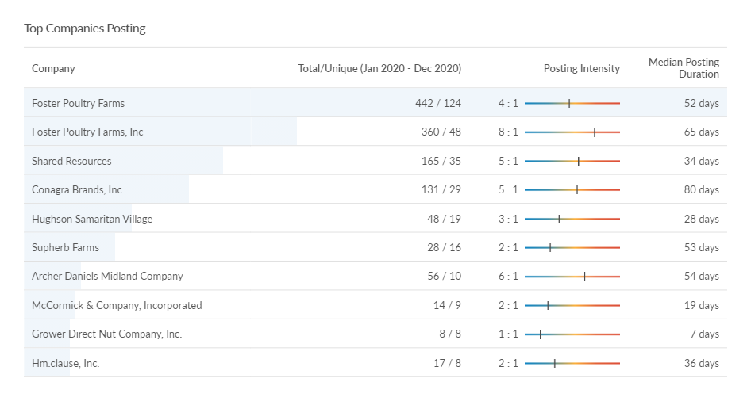

Top Qualifications for Agriculture Job Posts (Jan 2020 – Dec 2020):
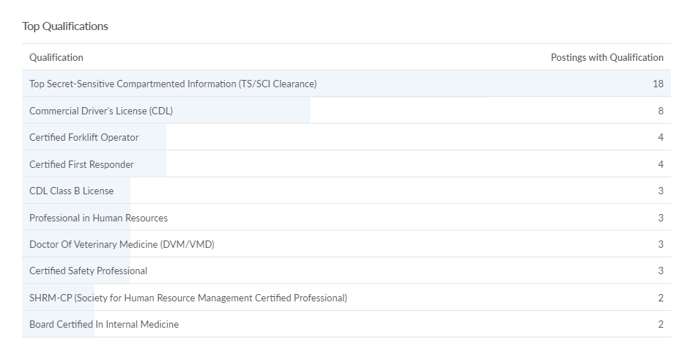

II. Health Care
1. Employment and Wage
Total Employed as of Q4 2020: 23,911
Percent of Growth in historical employment (Q4 2010 - Q4 2020), annual Growth rate: 2.07%
Projected Growth Over 5 Years (Q42020 - 2025), annual growth rate: 2.58%
Number of People Employed (Historical 10 years, Q42010 - Q42020): 19,484 23,911

Figure II.1: Health Care Historical Employment Trend in Stanislaus County from Q4 2010 to Q4 2020

Average Employee Wage (Historical 10 years, 2010-2020): $58,441 $81,447

Figure II.2: Health Care Historical Wage Trend in Stanislaus County from 2010 to 2020
2. Occupation
Top ten occupations by number of people employed in Health Care as of Q4 2020
Description | Employed in Health Care Industry as of Q4 2020 | Avg. Annual Earnings | Projected Job Change as of 2025
Registered Nurses | 4,093 | $121,076.80 | 463
Medical Assistants | 1,208 | $42,244.80 | 198
Nursing Assistants | 1,189 | $36,732.80 | 137
Medical Secretaries and Administrative Assistants | 1,135 | $41,579.20 | 137
Home Health and Personal Care Aides | 988 | $29,556.80 | 225
Licensed Practical and Licensed Vocational Nurses | 921 | $59,904.00 | 109
Dental Assistants | 749 | $40,976.00 | 96
Receptionists and Information Clerks | 706 | $34,673.60 | 80
Maids and Housekeeping Cleaners | 520 | $34,798.40 | 43
Medical and Health Services Managers | 515 | $143,561.60 | 133
Total Employed in Top 10 Occupations | 12,024
3. Job Postings
Top Ten Health Care Job Postings (Jan 2020 – Dec 2020):
Occupation | Unique Postings  Jan 2020 - Dec 2020 | Median Annual Earnings | Median Advertised Salary
Registered Nurses | 1,609 | $110,178 | $126,720
Speech-Language Pathologists | 431 | $135,387 | $70,400
Physicians, All Other; and Ophthalmologists, Except Pediatric | 248 | $304,697 | $257,024
Medical and Health Services Managers | 245 | $142,646 | $73,472
Physical Therapists | 206 | $122,512 | $89,600
Nursing Assistants | 195 | $34,403 | $37,504
Home Health and Personal Care Aides | 171 | $28,101 | $31,104
Family Medicine Physicians | 141 | $113,993 | $150,000
Physician Assistants | 137 | $141,066 | $156,416
Occupational Therapists | 122 | $105,810 | $84,480

Companies with highest number of distinct job posts – Health Care (Jan 2020 – Dec 2020):
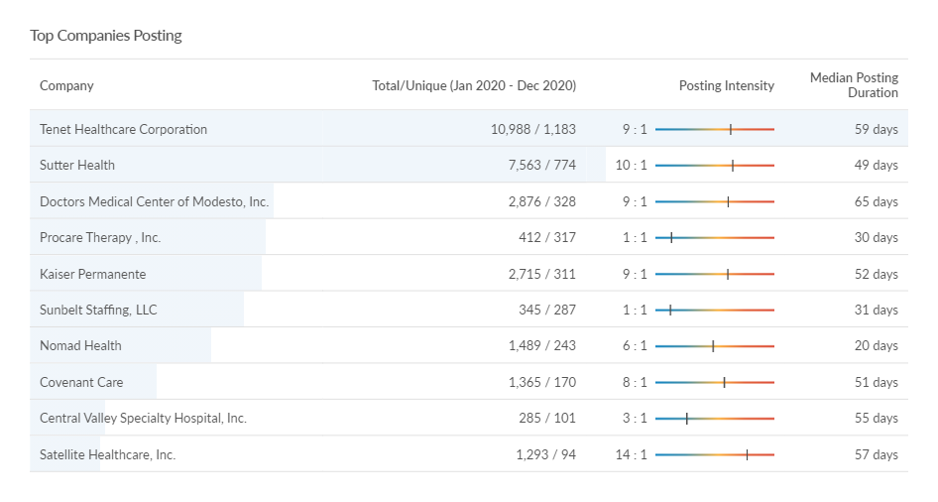

Top Qualifications for Health Care Job Posts (Jan 2020 – Dec 2020):
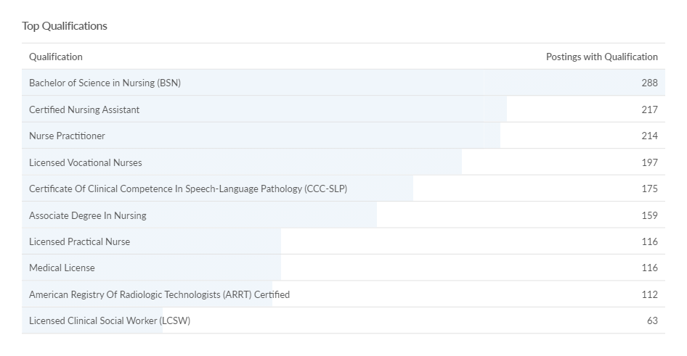

III. Manufacturing
I. Employment and Wage
Total Employed as of Q4 2020: 21,168
Percent of Growth in historical employment (Q4 2010 – Q4 2020), annual Growth rate: 0.20%
Projected Growth Over 5 Years (Q4 2020-2025), annual growth rate: (- 0.03%)
Number of People Employed (Historical 10 years, Q4 2010 – Q4 2020): 20,741 21,168

Figure III.1: Manufacturing Historical Employment Trend in Stanislaus County from Q4 2010 to Q4 2020

Average Employee Wage (Historical 10 years, 2010 – 2020): $51,247 $66,967

Figure II.2: Manufacturing Historical Wage Trend in Stanislaus County from 2010 to 2020
2. Occupation
Occupations by number of people employed in Manufacturing as of Q4 2020:
Description | Employed in Manufacturing Industry as of Q4 2020 | Avg. Annual Earnings | Projected Job Change as of 2025
Packaging and Filling Machine Operators and Tenders | 1,681 | $36,275.20 | (2)
Laborers and Freight, Stock, and Material Movers, Hand | 1,148 | $37,003.20 | 1
Slaughterers and Meat Packers | 910 | $29,931.20 | (123)
Industrial Truck and Tractor Operators | 805 | $42,036.80 | (5)
Sales Representatives, Wholesale and Manufacturing, Except Technical and Scientific Products | 635 | $73,569.60 | 5
Miscellaneous Assemblers and Fabricators | 622 | $38,563.20 | (38)
First-Line Supervisors of Production and Operating Workers | 570 | $67,184.00 | 22
Industrial Machinery Mechanics | 542 | $62,337.60 | 58
Packers and Packagers, Hand | 501 | $32,052.80 | (0)
Food and Tobacco Roasting, Baking, and Drying Machine Operators and Tenders | 482 | $36,233.60 | (25)
Total Employed in Top 10 Occupations | 7,895
3. Job Postings
Top Ten Manufacturing Job Postings (Jan 2020 – Dec 2020):
Occupation | Unique Postings Jan 2020 - Dec 2020 | Median Annual Earnings | Median Advertised Salary
Maintenance and Repair Workers, General | 123 | $47,050 | $63,104
Heavy and Tractor-Trailer Truck Drivers | 109 | $43,618 | $69,888
First-Line Supervisors of Production and Operating Workers | 103 | $62,982 | $53,248
Stockers and Order Fillers | 73 | $30,056 | $37,248
Marketing Managers | 69 | $145,974 | $112,640
Retail Salespersons | 59 | $29,994 | $29,120
Industrial Engineers | 58 | $86,882 | $66,816
Sales Representatives, Wholesale and Manufacturing, Except Technical and Scientific Products | 56 | $64,750 | $49,408
Helpers--Production Workers | 56 | $30,867 | $30,720
First-Line Supervisors of Retail Sales Workers | 52 | $41,538 | $66,304

Companies with highest number of distinct Postings – Manufacturing (Jan 2020 – Dec 2020):
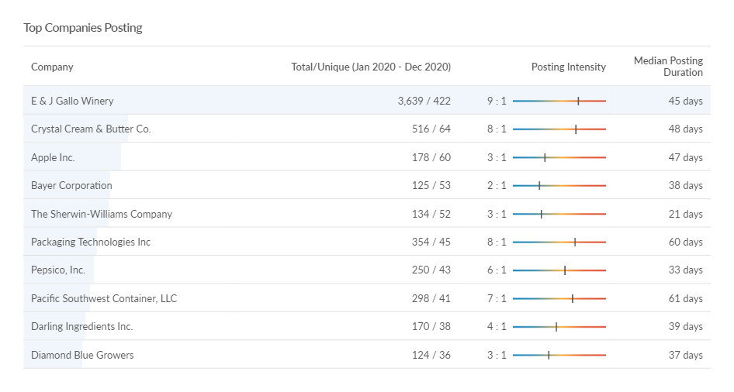
Top Qualifications for Manufacturing Job Posts (Jan 2020 – Dec 2020):
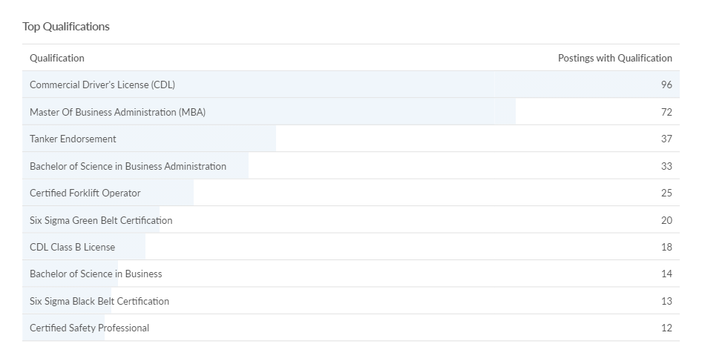

IV. Transportation and Warehousing
1. Employment and Wage
Total Employed as of Q4 2020: 8,799
Percent of Growth in historical employment (Q4 2010 – Q4 2020), annual Growth rate: 3.85%
Projected Growth Over 5 Years (Q4 2020 – Q4 2025), annual growth rate: 2.17%
Number of People Employed (Historical 10 years, Q4 2010 – Q4 2020): 6,028 8,799

Figure IV.1: Transportation and Warehousing Historical Employment Trend in Stanislaus County from Q4 2010 to Q4 2020

Average Employee Wage (Historical 10 years, 2010-2020): $41,182 $58,317

Figure IV.2: Manufacturing Historical Wage Trend in Stanislaus County from 2010 to 2020
II. Occupations
Occupations by number of people employed in Transportation and Warehousing as of Q4 2020:
Description | Employed in the Industry as of Q4 2020 | Avg. Annual Earnings | Projected Job Change as of 2025
Heavy and Tractor-Trailer Truck Drivers | 2,008 | $43,596.80 | 142
Laborers and Freight, Stock, and Material Movers, Hand | 1,624 | $37,003.20 | 253
Industrial Truck and Tractor Operators | 758 | $42,036.80 | 99
Stockers and Order Fillers | 429 | $33,321.60 | 96
Light Truck Drivers | 397 | $38,168.00 | 72
Packers and Packagers, Hand | 323 | $32,052.80 | 22
First-Line Supervisors of Transportation and Material Moving Workers, Except Aircraft Cargo Handling Supervisors | 228 | $56,950.40 | 33
Passenger Vehicle Drivers, Except Bus Drivers, Transit and Intercity | 194 | $36,691.20 | 34
Shipping, Receiving, and Inventory Clerks | 179 | $39,062.40 | 20
Bus and Truck Mechanics and Diesel Engine Specialists | 150 | $57,636.80 | 12
Total Employed in Top 10 Occupations | 6,290
III. Job Postings
Top Ten Transportation and Warehousing Job Postings (Jan 2020 – Dec 2020):
Occupation | Unique Postings  Jan 2020 - Dec 2020 | Median Annual Earnings | Median Advertised Salary
Heavy and Tractor-Trailer Truck Drivers | 1,980 | $43,618 | $64,896
Light Truck Drivers | 376 | $31,658 | $43,648
Passenger Vehicle Drivers, Except Bus Drivers, Transit and Intercity | 181 | $34,445 | $40,320
Laborers and Freight, Stock, and Material Movers, Hand | 87 | $32,968 | $34,432
Driver/Sales Workers | 86 | $42,370 | $45,760
First-Line Supervisors of Transportation and Material Moving Workers, Except Aircraft Cargo Handling Supervisors | 63 | $53,102 | $36,480
Stockers and Order Fillers | 45 | $30,056 | $45,760
Sales and Related Workers, All Other | 24 | $33,717 | $45,760
Industrial Truck and Tractor Operators | 20 | $42,598 | $33,920
Physical Therapists | 19 | $122,512 | Insf. Data

Companies with highest number of distinct job posts – Transportation and Warehousing (Jan 2020 – Dec 2020):
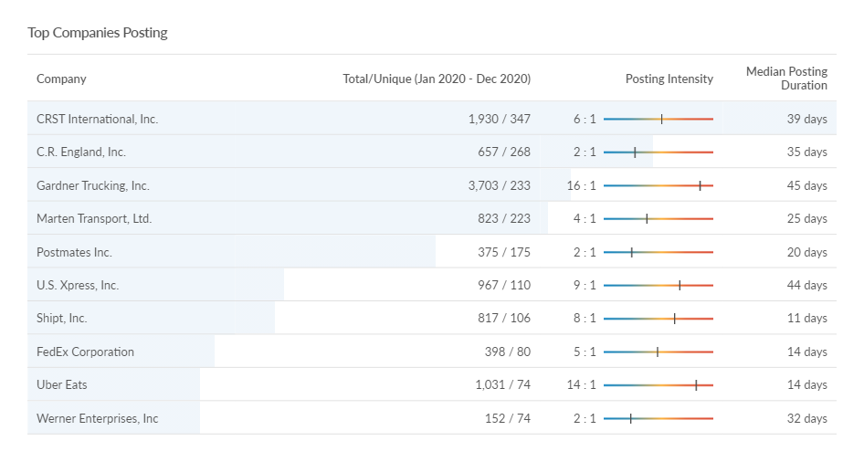
Top Qualifications for Transportation and Warehousing Job Posts (Jan 2020 – Dec 2020):
